Stranger than Fiction:

Writing from Real Life

One-day Writers' Workshop & Retreat
at the Rensselaerville Institute Conference Center

with
award-winning writer
Diane Gallo


Photo by Lady Ostapek

Saturday, May 14th, 2005
9:00 AM - 4:00 PM

Registration limited to18. $90 workshop fee includes coffee
service and lunch. For reservations and program information,
call Rensselaerville Institute Conference Center
http://www.RIConferenceCenter.com

Toll-free 1-800-682-9857
or 518-797-5100

This workshop is supported by a grant from Poets & Writers
www.pw.org
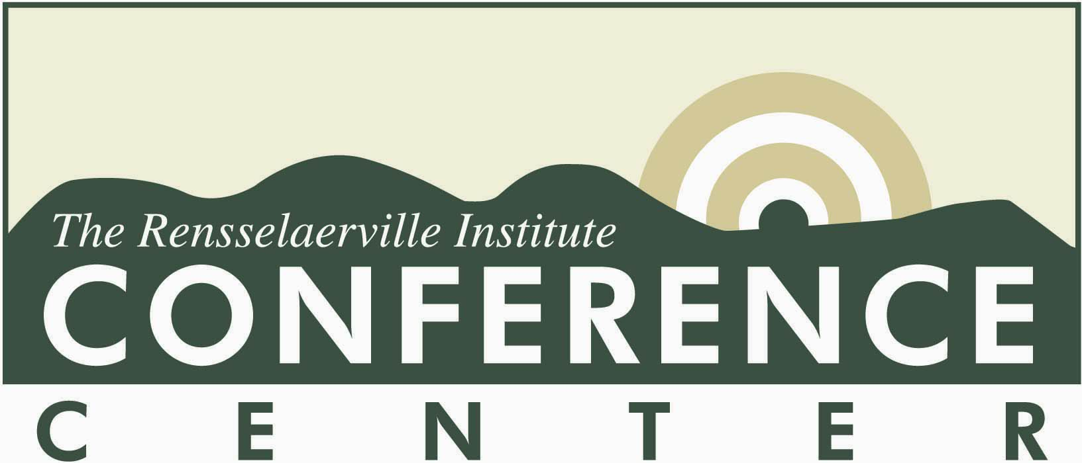

Stranger than Fiction:

Writing from Real Life

If you’ve always wanted to write ... or if you’ve always thought that real life is stranger than any fiction you could invent ... this workshop is for you. Whether you write for work, family, publication or for your self - and whether you’re a beginner or an experienced writer - this workshop will give you a jump-start into a story, a project or a lifetime of pleasurable writing

During this one-day writers’ retreat, you’ll follow a step-by-step journey that takes you from first idea and rough draft through polished manuscript. By the end of the day, you’ll understand how to make your writing sharp, clear and persuasive; skills you can immediately put into action in your personal and professional life.

You’ll leave with an outline of writing ideas based on important events and experiences taken directly from your own life, an understanding of key writing concepts to help you frame those stories with compelling images, a story conferencing technique to help you deepen and expand your writing, and an understanding of key revision concepts to help you expand, clarify, organize and polish your ideas.

Using step-by-step exercises, presenter Diane Gallo helps writers of all ages and at all stages develop a reflective approach that translates into personal and professional growth. She also addresses common writing blocks and tackles empowerment and other issues related to the writer’s craft and the writer’s life. For more than twenty years, Diane has integrated creative writing skills with ‘real life’ stories to create dynamic workshops that bring out the hidden writer in everyone. Using her proven methods, she has helped thousands of workshop participants get past the fear and into the pleasures of writing.

Stranger than Fiction: Writing from Real Life is great for writers and ‘non-writers’ alike - from individuals interested in honing their communications skills to writers’ groups, book clubs and family groups interested in preserving family stories and histories.

Workshop fee of $90 includes coffee service and lunch at the Huyck Carriage House Restaurant. Registration limited to18 participants. To make your reservation or to learn more about this program or the Conference Center, call (518) 797-5100 or toll-free: 1-800-682-9857.

This workshop is supported by a grant from Poets & Writers (www.pw.org).

Get motivated; get moving; get writing!
Get off that creative “but” and sign up today!

The Rensselaerville Institute www.rinstitute.org, the Capital Region’s “think tank with muddy boots,” enjoys an international reputation for nurturing creative minds and ideas. The Institute’s Conference Center is located on a beautifully landscaped 100-acre estate perfectly suited to writers at work.

Diane Gallo is a long time mentor with the Rensselaerville Institute’s Minds On program and a poet with the Geraldine Dodge poetry program. A master teaching artist and co-founder of the Association of Teaching Artists, Diane works extensively with schools and cultural institutions and is a presenter at language conferences and poetry festivals. She has done training and staff development for writers, artists, teachers, hospice professionals, social service organizations as well as one-on-one coaching and editing. An award-winning fiction writer, screenwriter and poet, in 2000 the Mid-Atlantic Foundation named Diane one of America’s 250 most gifted community artists. Pudding House Publications recently released a chapbook of her prose and poetry entitled Signs of Departure.

